Course Title
Manual Title
Version: September 2019
© Canada School of Public Service (20xx, Revised 20xx)

Table of Contents
Table of Contents 3
Formatting with Microsoft Word 2013 3
Introduction to Styles 3
Advantages of Styles 3
How to Show/​Hide the “Styles” Panel 3
Types of Styles 3
Built-in Styles 3
Hidden Formatting Symbols 3
Useful Shortcut Keys 3
How to Change the Document Theme 3
“Heading 1” Style 3
“Heading 2” Style 3
“Heading 3” Style 3
“Body Text” Style 3
“Caption” Style 3
List Styles (i.e. Bullets and Numberings) 3
“Figure” Style 3
Alt[ernative] Text 3
Alt Text for Figures 3
Alt Text for Tables 3
Working with Tables 3
Paragraph Attributes 3
How to Start New Pages 3
Hidden Styles 3
How to Display Hidden Styles 3
Body Text Indents – Level 1 to Level 3 3
Headings – Level 4 to Level 6 3
“List number (i)” Style 3
List Numberings – Level 2 to Level 5 3
“Lines” Style 3
“Normal” Style 3
“Quote” Style 3
“Subtle Emphasis” (or underline) Style 3
About This Course 3
Background and Intent 3
Learning Objectives 3
References 3
Course Timetable 3
Links to Other Courses 3
Module #, Exercise #: Title 3
Sample Module Plan 3
Module Plan 3
Notes to the Instructor 3
Supplementary Materials 3
Module #, Document #: Title 3
Appendices 3
Appendix A: Title 3
Answer Keys 3
Module #, Exercise # (suggested answer): Title 3
Course Slides 3

Formatting with Microsoft Word 2013

Introduction to Styles
The biggest question that is often asked is, “Why should I format with styles?” It appears to be more complicated than manually formatting using the “Home” ribbon tools. In reality, though, formatting with styles is actually easier—provided you have a well-designed template at your disposal. It can also be quicker, especially if keyboard shortcuts are used.
The core set of styles that have been defined within this template is sufficient for formatting the vast majority of documents, therefore custom styles should not be created unless absolutely necessary. If you find that there is a need for a particular style that cannot be found within the core set of styles, chances are it already exists but it may just be hidden. Refer to Section 0 to show the hidden styles.
Core set of styles.
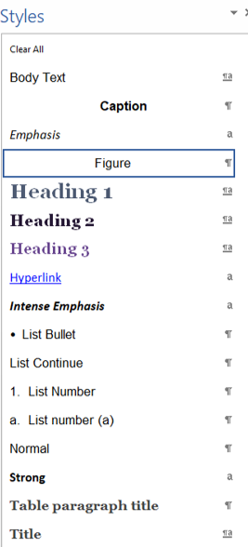

Advantages of Styles
Aside from time savings, as explained above, there are even greater advantages through the use of styles:
- Consistency: When text is formatted manually, it is necessary to remember what font style was used. This includes font face, font size, and font colour. Secondly, alignment, spacing, numbering, and border style are all possible formats for a paragraph. The moment one single attribute is different, you have lost consistency. Besides, it is much easier to remember a style name rather than all the attributes that it is composed of.
- Pagination: You have the ability to prevent page breaks where they should not occur, and to control where page breaks should occur. For example, the paragraph preceding a list should never be separated from the first bullet, therefore a “Paragraph keep with next” attribute must be used.
- Ease of future maintenance: Mass updates to a document can be made by simply modifying individual styles. For example, if the spacing between paragraphs need to be increased, then modifying the “Body Text” style will achieve that goal within a matter of seconds. It would not be necessary to go through the entire document paragraph-by-paragraph and manually adjusting the “space before” and “space after” attributes.
- Time savings: When a document is properly formatted with styles, then less time is required for the Desktop Publishing team to perform a quality assurance on the entire product. In turn, this will accelerate the turn-around time for the formatting request.
- Automation: As seen on page 3 of this document, the Table of Contents is automatically created thanks to the ties it has to Word’s built-in heading styles. As long as the proper paragraphs are styled using “Heading 1” or “Heading 2”, the TOC has corresponding styles called “TOC 1” and “TOC 2” that extract the right headings to construct the list.
- Convert to other formats: Should there ever be a need to convert a Word document to a PDF file, or to publish a document to the Web, then the heading styles will easily convert to the proper tags—i.e. <H1>, <H2>, and <H3>—thereby maintaining the logical structure of the document. Regular body paragraphs will default to using <P> tags.
- Accessibility: Finally, to satisfy the Treasury Board’s initiative to ensure that documents and Web sites are as accessible as possible, styles are essential if there is any hope of meeting this mandate. Certain styles instruct screen readers to announce whether the paragraph is a heading or a list bullet. Without styles, formatting the paragraphs in any other way would not make this possible.

How to Show/​Hide the “Styles” Panel
There are two methods to display the “Style” panel:
- Click the corner of the “Styles” group within the “Home” ribbon.
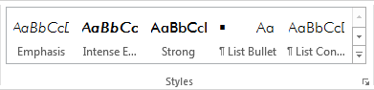
- Press the shortcut key <Alt+Ctrl+Shift+S>.

Types of Styles

Paragraph Styles
Paragraph styles apply formatting to an entire paragraph without having to select any text, therefore the cursor can be placed anywhere within a paragraph before selecting the style name (or pressing the associated shortcut key). A paragraph style is identified within the “Styles” panel by a pilcrow (). Even if a few characters or a few words are selected within a paragraph, applying a style will affect the entire paragraph regardless.
If you need to apply the same style to multiple paragraphs all at once, then you can select two or more consecutive paragraphs first. In order to select non-consecutive paragraphs, press and hold the <Ctrl> key while selecting with the mouse.

Character Styles
Character styles (identified within the “Styles” panel by an symbol) only affect text, therefore text must be selected before applying the style. If no text is currently selected, then any typed text that immediately follows will take on that style. The moment the cursor is moved away from the current location, the style will be deactivated.
The following character styles have been defined within the template:
- “Emphasis” style (i.e. italic). Italics should be used sparingly because those with Dyslexia find it difficult to read. The shortcut key <Ctrl+I> may be used, but do not use the “Italic” icon within the “Home” ribbon, “Font” group.
- “Strong” style (i.e. bold). The shortcut key <Ctrl+B> may be used, but do not use the “Bold” icon within the “Home” ribbon, “Font” group.
- “Intense Emphasis” style (i.e. bold italic). Do not use the “Bold”+“Italic” icons within the “Home” ribbon. There is no shortcut key assigned to this style.

Linked Styles
Some styles serve double duty in that they can apply to specific characters or entire paragraphs, depending on whether text is selected or not. Selected text will take on the character style, and unselected text will take on the paragraph style. Linked styles are identified within the “Styles” panel by a symbol.

Table Styles
When the cursor is placed inside any cell within a table, the “Design” ribbon becomes available. Within the “Table Styles” group, two styles have been defined with very different appearances.
- The “Table (standard)” style has borders, and all cells have a default padding of 0.03” on the top and bottom, and 0.08” on the left and right. A header row allows you to specify column headings which will repeat themselves on each new page.
- The “Table (tight)” style has no borders and no cell padding. It also does not have a header row. Because there are no borders, this style would never be used for displaying table data. The main purpose is for designing page layouts that cannot otherwise be created using the standard tools available in Word. This style should be avoided if at all possible.

Built-in Styles
No matter what version of Word you are using, there is automatically a set of default styles that are available with every installation of the software. But through the evolution of Word, newer versions come with more built-in styles than older versions. For example, Word 95 contains 154 built-in styles, whereas Word 2007 and above contain 267 built-in styles. The advantage that built-in styles have over custom styles is that their names have already been translated into other languages, therefore a style such as “Heading 1” in English would be called “Titre 1” if the user’s Word installation was in French.

Hidden Formatting Symbols
These symbols are representations of “invisible” characters. In other words, they do not form part of any content and therefore will not be printed. They are purely for formatting purposes for proper paragraph flow and pagination.
The table below summarizes some common formatting marks and their behaviour.
Name (Symbol) | Shortcut | Description
Space (·) | Space | A regular space that is a word separator.
Non-breaking space (°) | Ctrl+Shift+Space | A space that cannot separate two words upon a line wrap.
Optional hyphen (¬) | Ctrl+Hyphen | Hyphenates a word onto two lines only if necessary.
Non-breaking hyphen (–) | Ctrl+Shift+Hyphen | A hyphen that cannot separate two words upon a line wrap. With formatting marks turned off, appears as a regular hyphen (-).
Paragraph mark (¶) | Enter | Signifies the end of a paragraph. It is literally within this mark that all paragraph formatting attributes are stored.
End of table cell / End of table row (¤) | [none] | Although this mark cannot be physically typed, it is good to recognize because if a table row spans across two pages, you will be able to see if it is one or two cells.
Manual page break | Ctrl+Enter | Forces a new page. Do not use, as explained in Section 0.
Section break | [none] | Forces a new page, but also allows the new section to have different headers and/or footers, or to change the page setup such as orientation or margins.

How to Show/Hide Hidden Symbols
There are three methods available:
- The quickest method is to use the keyboard shortcut <Ctrl+Shift+8>.
- Select the “Home” ribbon, “Paragraph” group, “Show/Hide ¶” icon.
- Open the “File” menu, “Options”, “Display” tab. Select or deselect the “Show all formatting marks” checkbox under “Always show these formatting marks on the screen”.

Useful Shortcut Keys
Shortcut | Description | Shortcut | Description
Ctrl+Z | Undo | Ctrl+A | Select all
Ctrl+Y | Redo | Ctrl+K | Insert/modify hyperlink
Ctrl+X | Cut | Alt+Ctrl+1 | “Heading 1” style
Ctrl+C | Copy | Alt+Ctrl+2 | “Heading 2” style
Ctrl+V | Paste | Alt+Ctrl+3 | “Heading 3” style
Ctrl+B | Bold (“Strong” style) | Ctrl+Shift+L | “List Bullet” style
Ctrl+I | Italic (“Emphasis” style) | Ctrl+Shift+N | “Normal” style
Ctrl+U | Underline (“Subtle Emphasis” style) | Ctrl+Shift+8 | Show/hide formatting symbols and hidden text
Ctrl+L | Left align text | Ctrl+Shift+C | Copy formatting
Ctrl+E | Center text | Ctrl+Shift+V | Paste formatting
Ctrl+R | Right align text | Ctrl+Space | Reset character style
Ctrl+P | Print document | Ctrl+Q | Reset paragraph style
Ctrl+F2 | Print preview | Alt+Ctrl+F | Insert footnote
Ctrl+O | Open document | Ctrl+= | Subscript
Ctrl+W | Close document | Ctrl+Shift+= | Superscript
Ctrl+N | New document | Ctrl+D | Open “Font” dialog box
Ctrl+S | Save document | Alt, O, P | Open “Paragraph” dialog box
F12 | Save As command | Ctrl+Shift+A | Toggle all-caps on/off
Ctrl+F | Find | Ctrl+Shift+H | Toggle hidden text on/off
Ctrl+PgDn | Go to next search result | Shift+F3 | Cycle “Change Case” options
Ctrl+PgUp | Go to previous search result | F4 | Repeat last action
Ctrl+H | Search and replace | F9 | Update field
Ctrl+G or F5 | Go to page number | Ctrl+Shift+E | Toggle tracked changes on/off

How to Change the Document Theme
If there is ever a need to change the branding of a document, there is a feature of Word that can update the overall theme rather than having to modify individual styles. The theme consists of two separate components – colours and fonts – which can be modified independently using the “Design” ribbon, “Document Formatting” group, “Colors” or “Fonts” icons.

“Heading 1” Style
The heading above uses the “Heading 1” style. Each major section within the document uses this style, therefore the style was designed to always start on a new page. The shortcut key for applying the style is <Alt+Ctrl+1>.

“Heading 2” Style
This style is used for subtopics within a Heading 1 section. The shortcut key is <Alt+Ctrl+2>.

“Heading 3” Style
This style is used for subtopics within a Heading 2 section. The shortcut key is <Alt+Ctrl+3>. A level 3 heading is the last heading style that has a shortcut key. Be careful to not have a level 3 heading directly beneath a level 1 heading. Skipping heading levels is a failure in terms of Accessibility.

“Body Text” Style
This style automatically spaces paragraphs by 6 pt (both above and below), therefore it is never necessary to have an empty paragraph mark on a line of its own in order to add space between paragraphs. The shortcut key is <Ctrl+Shift+B>. If extra spacing is needed, refer to Section 0. In addition, this style should never be used within a table.

“Caption” Style
Captions provide a quick explanation of the item that follows, and therefore should be limited to roughly 150 characters in length. For example, a caption for a figure might explain why it is being shown, or it may be used to substitute the alt text of the figure itself. (Refer to Section 0 for more information about alt text.) Captions are optional, but if used they should be relevant to the context.

List Styles (i.e. Bullets and Numberings)
“List Continue” typically precedes a bulleted or numbered list. The shortcut key is <Ctrl+L>.
- “List Bullet” (<Ctrl+Shift+L>). Automatically appears after pressing <Enter> on a paragraph that uses the “List Continue” style.
Aside from bullets, there are three other list styles available:
- “List Number” uses Arabic numerals.
- “List number (a)” uses lowercase alphabetic characters. If uppercase letters are needed, then a new multilevel list must be created (which is beyond the scope of this document).
To add spacing between each numbered paragraph, refer to Section 0.

“Figure” Style
This style is mainly used to center an image on the page. The shortcut key is <Ctrl+Shift+F>. Do not use it to center regular paragraphs of text.
Caption optional for images depending on context. (Refer to Section 0.)
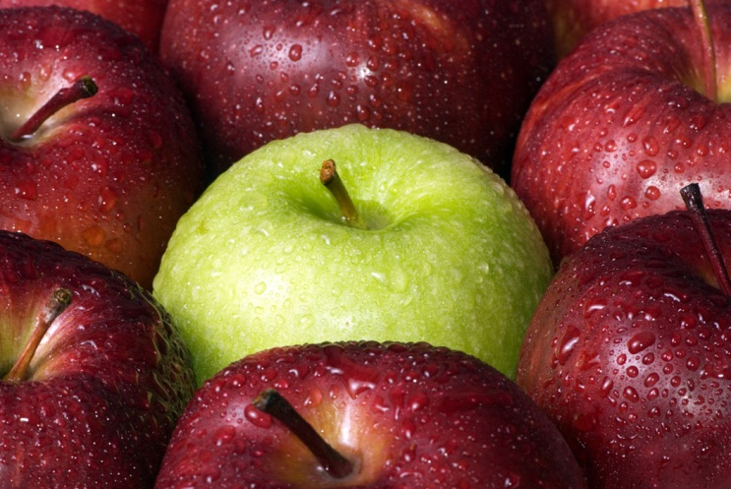

Alt[ernative] Text
In general, figures, charts, tables, and complex diagrams should always contain alt text as long as they convey useful information that a sighted user would normally see. A significant amount of experience is necessary before one can fully understand when to use alt text, how to construct short but meaningful alt text, and how to write alt text that does not duplicate information from the immediate surroundings. With that said, however, not all objects have an alt text attribute—which is the case with SmartArt.
Alt text should be short and concise—preferably less than 150 characters. Describe the figure based on the context and surroundings of the figure itself. The primary question is: “Why is the figure being shown?”, rather than “What is the figure showing?” Redundant information such as “Image of …” or “Graphic of …” can be excluded because screen readers automatically announce “Graphic” prior to reading the alt text.
In the example in Section 0, the “what” alt text could be “A green apple surrounded by red apples.” The “why” alt text could be “Apples come in many different colours, such as red and green.”

Alt Text for Figures
Alt text is accessed by right-clicking on the image and selecting “Format Picture”. Click on the “Layout & Properties” icon (), then expand “ALT TEXT”. Only use the “Description” field, and always leave the “Title” field empty.

Alt Text for Tables
Since tables can contain many columns and many rows, it is highly recommended to provide a caption for the table which acts as a short description. Similar to the explanation provided in Section 0, short descriptions should be roughly 150 characters in length.
The alt text for a table is accessed by right-clicking anywhere inside a table cell and selecting “Table Properties”. Select the “Alt Text” tab, and enter a long description using the “Description” field. Leave the “Title” field empty.

Working with Tables

“Table (standard)” Style
This style is defined as having a header row using the “+Headings” font. Only the header row has the “Paragraph keep with next” attribute to allow it to always stick to the following row. The background shading helps differentiate it from the remaining cells of the table. The entire table uses a solid border on the entire grid—not just the outside border. The default cell margins are 0.03” top and bottom, and 0.08” left and right.
Table using the “Table (standard)” style.
Column 1 | Column 2
“Table paragraph title” style  “Normal” style. | Note: Empty cells should not be left empty. A non-breaking space or a hyphen is a satisfactory technique for screen readers.
 | The blank cell to the left contains a non-breaking space. Press <Ctrl+Shift+8> to view the hidden formatting symbol.

“Table (tight)” Style
This style does not have a header row, nor any other formatting for that matter. Its main use is for layout purposes, such as creating exact-width and/or exact-height cells.
Table using the “Table (tight)” style.
Signature |  | Date

“Table paragraph title” Style
As the name suggests, this style is to be used only within tables when there is a need to have subsections within a single cell. The shortcut key is <Ctrl+Shift+T>. The style is defined as having a 6 pt space after but no space before. In addition, the “Paragraph keep with next” attribute is not used, otherwise it may cause the current row to stick with the next row. Do not use the “Title” style within tables.

“Normal” Style
This style should be used for all paragraphs except titles (as explained in Section 0) and lists. Do not use the “Body Text” style within tables, because it contains a 6 pt space before.
If spacing is needed between paragraphs, manually add a “paragraph space after”, but never add a space before. (Refer to Section 0.) The last paragraph of a cell does not need a space after.

“Keep with next” Paragraph Attribute
The behaviour of this attribute is not as expected when used within a table. The attribute will only have an effect if applied to the first paragraph within the cell within the first column of a table. If used on the second, third, fourth, etc. paragraph within a cell, the attribute will be ignored. Never use this attribute within the last row of the table.

“Keep lines together” Paragraph Attribute
This attribute is completely ignored when used within a table, therefore it is impossible to prevent a paragraph from being split onto two pages. The best that can be done is to apply a “Paragraph page break before” attribute, however care must be taken to verify the pagination if content were to shift due to future additions or deletions.

Lists
It is possible to use the same styles as those listed in Section 0 within a table. However, paragraphs preceding a bulleted or numbered list do not use the “List Continue” style, because it contains a “paragraph keep with next” attribute as well as a 6 pt space before.

Blank Cells
It is a good practice to enter some kind of character within blank cells. It is most common to use a non-breaking space (<Ctrl+Shift+Space>), but in the case of columnar data – such as statistics or financials – a hyphen or en-dash (<Ctrl+Num Pad Minus>) may be used. Press <Ctrl+Shift+8> to view the hidden formatting symbols.

“Title” Style
This style is used for minor headings which do not need to be included in the table of contents. For example, exercises typically have three subsections called “Time”, “Purpose”, and “Instructions”. (Refer to page 3 for a sample exercise.) The shortcut key is <Ctrl+T>. The style is defined as having a 6 pt space and 6 pt space after, as well as “Paragraph keep with next”. Do not use “Body Text”+”Strong”.

Paragraph Attributes

Spacing between Paragraphs
The proper technique to increase or decrease the spacing between paragraphs is to use the “space before” and “space after” attributes within the “Home” ribbon, “Paragraph” group, “Paragraph Settings”, “Indents and Spacing” tab.
How to access “Paragraph Settings”.
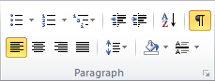
Paragraph settings
The “Paragraph” dialog box, “Indents and Spacing” tab.
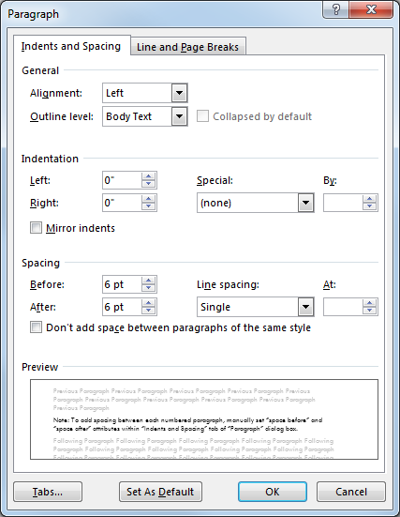

“Keep with next” Paragraph Attribute
If a paragraph needs to “stick” to the paragraph that immediately follows it, use the “Home” ribbon, “Paragraph” dialog box, “Line and Page Breaks” tab, “Keep with next” checkbox under “Pagination”. This prevents the paragraphs from being accidentally split onto two pages.
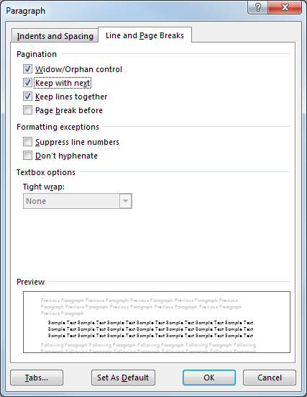

“Keep lines together” Paragraph Attribute
All paragraph styles (with the exception of “Normal”) have been defined to have the “Keep lines together” attribute enabled, which prevents the paragraph from being separated onto different pages. The attribute can be found within the “Home” ribbon, “Paragraph” dialog box, “Line and Page Breaks” tab. For extremely long paragraphs (i.e. over 20 lines in length), consider breaking them into smaller paragraphs, or manually disable this attribute.
The “Paragraph” dialog box, “Line and Page Breaks” tab.
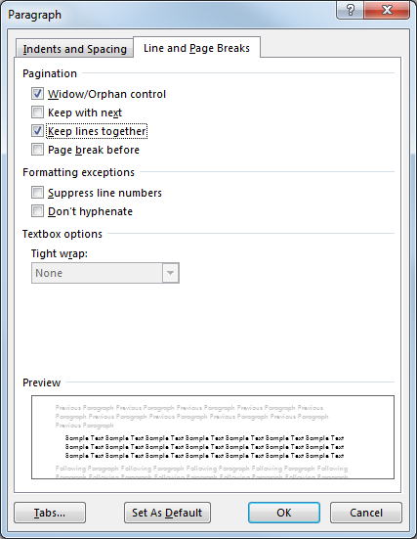

How to Start New Pages
There are 3 methods for starting content on a new page. Each method has its advantages and disadvantages depending on the situation. Keep in mind that starting a new page should only be used if it is warranted. Do not start a new page simply because the content is too close to the bottom of a page. Manual page breaks interfere with the natural pagination that Word is capable of handling automatically.

Manual Page Break
This is inserted by selecting the “Page Layout” ribbon, “Breaks” icon, “Page” option under “Page Breaks”. The shortcut key is <Ctrl+Enter>. Avoid this method if at all possible; it is more proper to use the method described in Section 0.

“Page break before” Paragraph Attribute
This is the preferred method by using the “Paragraph page break before” attribute. A typical example is having all exercises start on a new page.
When used on a paragraph that has a space before, it is sometimes necessary to manually remove it (<Ctrl+0>).

Section Breaks
Section breaks provide many more options compared to a regular page break. Some of these options include:
- Next Page: This option essentially has the same effect as a regular page break.
- Continuous: This option does not actually start a new page. Instead, it is meant to create a subsection within the same page (e.g. columns).
- Even Page: Causes the following page to start on an even page. This is typically used to allow for tab indexes.
- Different odd and even: This option is typically used to create a different header or footer for odd and even pages. Within this template, the page number is in the bottom-right corner for odd pages and bottom-left for even pages.
- Different first page: In the case of this template, the “Different first page” option was used to add a graphic to only the front cover. Keep in mind that this “first page” has no correlation to the first odd page. For this reason, it is possible to have a different header or footer on the front cover compared to the rest of the document.
Section breaks are also useful if a different size or orientation (e.g. landscape mode) or different margins are needed. With that said, however, it is not very practical to mix paper sizes (e.g. letter, legal, ledger) if the intended output is a printed manual.
Caution: Use section breaks sparingly since they can be difficult and confusing to work with—especially if they involve headers or footers.

Hidden Styles
Certain styles were deliberately hidden because they are not commonly used. This allows the “Styles” panel to be less cluttered.

How to Display Hidden Styles
To make hidden styles available for formatting, follow these steps:
- With the “Styles” panel open, click on the “Options” link in the bottom-right corner.
- Select “All styles” from the listbox under “Select styles to show”.
- Press the “OK” button.
Note: It is a good idea to revert the “Styles” panel to show only the recommended styles by selecting “In current document” in step 2 above once the hidden styles are no longer needed.

Body Text Indents – Level 1 to Level 3
These styles indent paragraphs by an additional 0.25” from one another.
“Body Text Indent” style (indented 0.25”)
“Body Text Indent 2” style (indented 0.5”)
“Body Text Indent 3” style (indented 0.75”)

Headings – Level 4 to Level 6
It is recommended to not exceed three levels of headings within a document. In the event that more levels are required, then “Heading 4”, “Heading 5”, and “Heading 6” may be used. Although Word allows for 9 levels, traditional Web pages are limited to 6, therefore “Heading 7”, “Heading 8”, and “Heading 9” were deliberately not defined.

“List number (i)” Style
This style uses lowercase Roman numerals. It is not recommended to use this style because Roman numerals are more difficult to read, and larger numbers (e.g. xvii and xviii) do not fit within the 0.25” indentation. If uppercase letters are needed, then a new multilevel list must be created (which is beyond the scope of this document).

List Numberings – Level 2 to Level 5
Each level is indented by 0.25”. A matching “List Continue” style exists for each list level. Depending on the situation, it is possible to use the <Alt+Shift+Right Arrow> or <Alt+Shift+Left Arrow> shortcut keys to change the list level. But if the intended behaviour does not function properly, it is safer to use the “Home” ribbon, “Paragraph” group, “Multilevel List” icon, “Change List Level” function.

“Lines” Style
Typically used for exercises with questions requiring a written answer. The paragraph preceding the lines should use “List Continue”.
To prevent lines from being split onto two pages, select all but the last paragraph, then add
the “Paragraph keep with next” attribute. Note that line wraps do not work as expected; it is
necessary to press <Enter> for each new line. The font is dark blue to imitate an ink pen.

“Normal” Style
This style has the same functionality as “Clear All” within the “Styles” panel. It can also be applied using the shortcut key <Ctrl+Shift+N>. Text within table cells use this style by default when a table is inserted using the “Insert” ribbon, “Tables” group, “Table” icon.

When to Use “Body Text” and “Normal”
If multiple lines of text do not need to be spaced apart, there are two techniques that can be used. (If not already turned on, show all formatting symbols by pressing <Ctrl+Shift+8> to see the soft and hard returns.
- “Body Text” style with each line separated by a soft-return (<Shift+Enter>).
241 Cité-des-Jeunes Boulevard
Gatineau, Québec J8Y 6L2
Email: csps.registrar-registraire.efpc@canada.ca
Fax: csps.registrar-registraire.efpc@canada.ca
Phone : 1-866-703-9598
- “Normal” style with each line separated by a hard-return (<Enter>). This technique may require that all but the last line have the “Paragraph keep with next” attribute. For example, the following is the contact information for GCcampus:
241 Cité-des-Jeunes Boulevard
Gatineau, Québec J8Y 6L2
Email: csps.registrar-registraire.efpc@canada.ca
Fax: csps.registrar-registraire.efpc@canada.ca
Phone : 1-866-703-9598
The only difference between the two techniques is that “Body Text” inherently has a 6 pt space before and space after, whereas “Normal” does not.

“Quote” Style
“List Continue” can be used if there is a preamble to the quote. The following quote should use the “Paragraph keep with next” attribute if it is to be joined to the source of the quote:
The “Quote” style is italicized and indented by 0.25” on the left and right.
— Source of quote (em-dash followed by source name)
Use the ”Strong” character style within a “Quote” paragraph style to bold individual words. It is interesting to note that if the “Emphasis” style is applied to a “Quote” style, the text will actually be unitalicized because the character style inverts the font style of the underlying paragraph definition.

“Subtle Emphasis” (or underline) Style
This style imitates the underline character style. Do not use the “Underline” icon within the “Home” ribbon, or <Ctrl+U>. Note that underlining should not be used at all for Accessibility reasons because it makes the text appear to be a hyperlink.

About This Course
Body Text.

Background and Intent
Body Text.

Learning Objectives
Body Text.
Learning Objectives by Module
Module | Learning Objectives
Module 1 | Module 1 learning objective.
Module 2 | Module 2 learning objective.
Module 3 | Module 3 learning objective.

References
Body Text.

Course Timetable
Time | Day 1 | Day 2 | Day 3 | Day 4 | Day 5
08:30
10:15 |  |  | Break
10:30
12:00 |  |  | Lunch
13:00
15:00 |  |  | Break
15:15
16:30 |  |  | End of day

Links to Other Courses
Body Text.

Module #, Exercise #: Title

Time
15 minutes

Purpose
To familiarize participants with various accessibility requirements.

Instructions
- Text for instruction number 1. (Spacing before and after can be added manually.)
- Text for instruction number 2.
- Text for instruction number 3.

Sample Module Plan

Module Plan
Learning Objective No.: | Performance:
Enabling Objective No.: | Performance:
Starting/​Ending Time:  Day: 1 Hours: 08:30 to 09:00 | Duration: 30 minutes

Teaching Points | Methodology/​Key Messages | Time (min.)

Notes to the Instructor
Body Text.

Supplementary Materials

Module #, Document #: Title
Body Text.

Appendices

Appendix A: Title
Body Text.

Answer Keys

Module #, Exercise # (suggested answer): Title
Body Text.

Course Slides
Copies of course slides are provided in this section for your use and reference. You may want to add your own notes on these pages as the course progresses.

